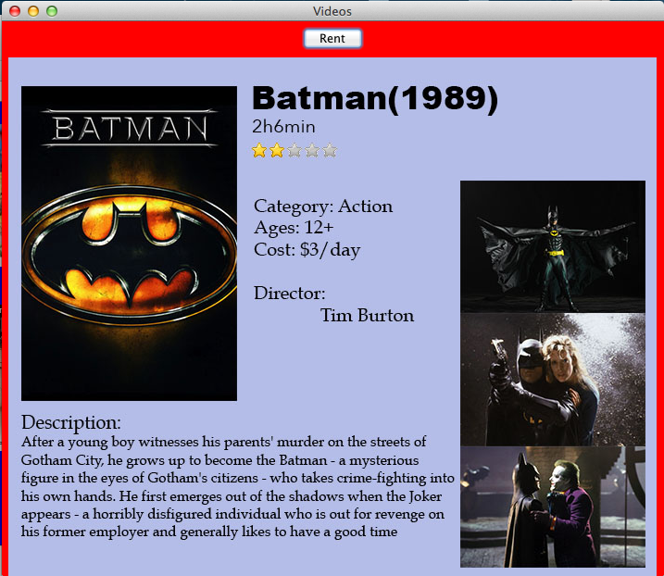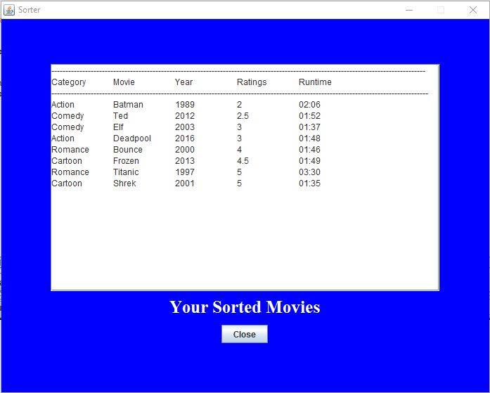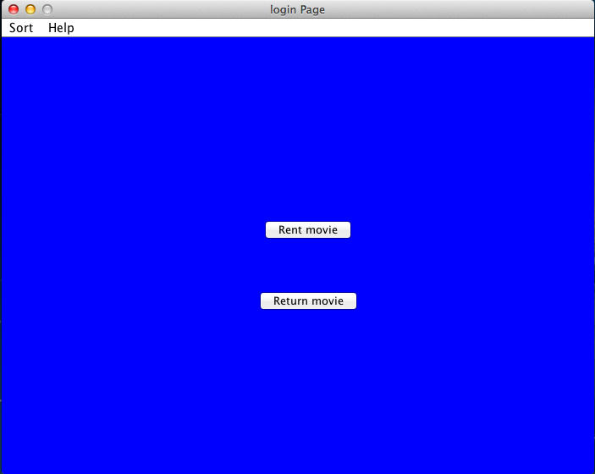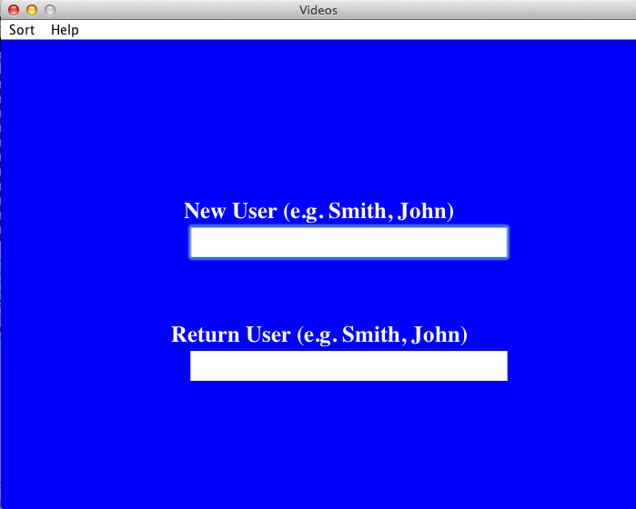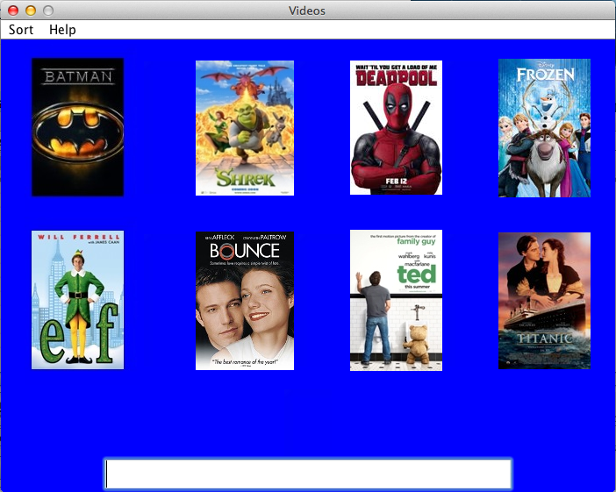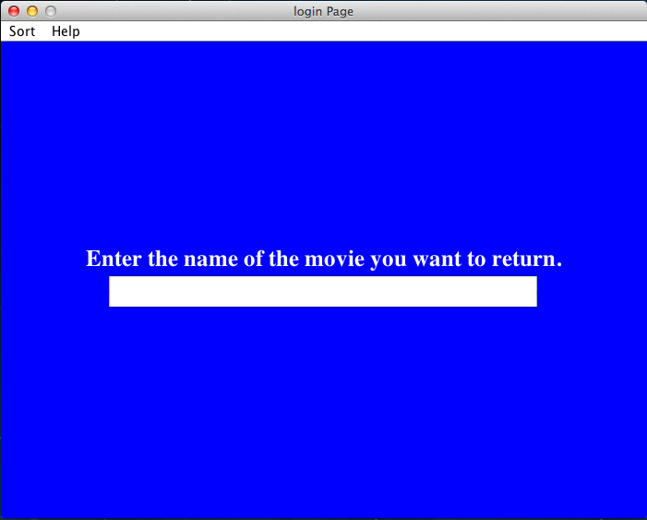

Our product is designed to be quick and efficient, it allows users to manually sign out movies that they want to watch.

There are in total of 8 movies to choose from and the following steps will get you started!

Joe Lin, Sailesh Nankani and Annie Sun

Video Rental

double check the spelling and capitalization. (Eg. Deadpool)

**Stage 2**

New User:

Enter the movie name that you would like to rent and press “Enter”,

Ps: you could always rent out multiple movies, just need to go through the process again!

top if you would like to rent the movie.

**Stage 4**

New User& Return User:

A detailed description of the movie you have chosen will pop up; click “Rent” on the

names, year, ratings or runtime. (Eg. Image showing videos sorted by ratings.)

**Stage 3**

There is a sort option in the menu bar, you can always choose to sort the movies by categories,

Option 2: Rent Movies

Enter the movie name that you would like to rent and press “Enter”, double check the spelling and capitalization (Eg. Deadpool)

If you are a return user, enter your full name and press “Enter” (Eg. John Smith)

**Stage 1**

If you are a new user, enter your full name and press “Enter” (Eg. John. Smith)

OR

Return User:

Choose whether you want to rent movies OR return movies

Option 1: Return Movies

Enter the movie name and press “Enter” until you see “Record deleted”